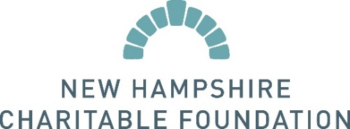
Press Release: Instructions and Template
We welcome you to use the following template to draft a press release announcing your grant from the New Hampshire Charitable Foundation. When sending the press release to your media contacts, we recommend including the text of the release in the body of the email as well as including it as an attachment.
EMAIL SUBJECT LINE: PRESS RELEASE: [Insert Press Release Title]
FOR IMMEDIATE RELEASE
CONTACT:
Contact Name
Contact Title
Organization
Phone Number
Email Address
Organization receives grant from the New Hampshire Charitable Foundation to (brief description of how the grant will be used. Ex: increase healthcare access for low-income families).
Organization recently received a $X,XXX grant from the New Hampshire Charitable Foundation. The grant will help further Organization’s mission of ____________________________ by _______________________________________.
[If desired, insert more information about the program funded by the grant]
About Organization
Place your organization’s boilerplate here: 2-5 sentence summary of the organization’s mission, including website and/or phone number.
About the New Hampshire Charitable Foundation
The New Hampshire Charitable Foundation is New Hampshire’s statewide community foundation, founded in 1962 by and for the people of New Hampshire. We are the place where generosity meets the dedication and ingenuity of nonprofits and the potential of New Hampshire students. For six decades, thousands of people have entrusted their charitable resources to the Foundation, creating a perpetual source of philanthropic capital and making it possible for the Foundation to award more than $60 million in grants and scholarships every year. For more information, please visit www.nhcf.org or call 603-225-6641.

