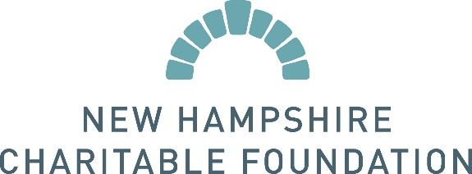
The Caroline and Martin Gross Fellowship
c/o New Hampshire Charitable Foundation
37 Pleasant Street • Concord, NH 03301-4005
800-464-6641 • 603-225-6641 • www.nhcf.org

2022 NOMINATION FORM

Date:

Nominator’s Name: | Daytime phone #:

Address:

Title or Position: | Email:
Nominee’s Name: | Daytime phone #:
Organization Name:
Address:
Title or Position: | Email:

Nomination Requirements:
Please submit this nomination form along with the information below by Friday, February 11, 2022 using one of the following methods:
Email: Jessica.Kierstead@nhcf.org
Mail: New Hampshire Charitable Foundation, Attn: Jessica Kierstead, Caroline and Martin Gross Fellowship, 37 Pleasant Street, Concord, NH, 03301

Please briefly address the following points:
These boxes will expand to accommodate your answer, and you can cut/paste from another document.

1. How long and in what capacity have you known your nominee?

2. Please evaluate your nominee’s leadership potential; ability to take on increased responsibility; skill in building consensus and finding creative solution to problems.

3. Please tell us why your nominee would particularly benefit from the Fellowship and the Kennedy School Program.

4. Please comment on your nominee’s work record, professional potential, and personal qualities. A copy of a recent resume would be helpful but is not required.

5. (OPTIONAL) If there are others who support and second this nomination, please attach brief comments from them, along with their names/titles, etc.

