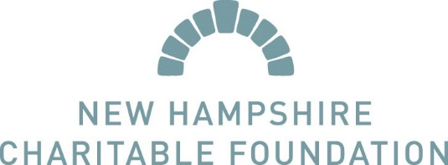

This document is to be used as guide for preparing your Unrestricted Grant concept paper and/or application and is not intended to serve as your concept paper or application. All concept papers and applications must be submitted via our online grant portal. We will not accept paper or emailed concept papers or applications.

As you are considering preparing your application, consider the following information when determining the grant size you will request:

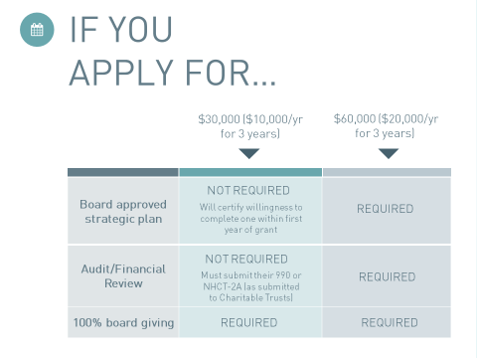

At the concept paper stage you will be required to upload your board approved strategic plan and your audit or financial review, and certify that you have 100% board giving. If your audit or review is still being finalized when the concept paper is due, you will asked to certify that the document will be available for upload at the time of the full application submission.

Please Note! Your GrantSource Profile, including your mission, organization description, organization budget and board list makes up part of your concept paper and full application. These components will be read by reviewers as they consider both your concept paper and, if invited, your full application. Make sure your profile is up to date!

Concept Paper:

- What has been your organization’s impact on your community or your constituents in recent years? Please quantify scale of impact where possible. (350 words)
- Provide a brief description of your current priority programmatic and organizational goals. (250 words)
- Briefly describe your short- and long-term strategies for addressing goals, both programmatic and organizational. (250 words)

Application:

Please Note! You will only be required to complete the application if you are invited to do so following submission of your concept paper. You will be notified of this by the dates posted on the website.

Through our unrestricted grants, we are seeking to support nonprofits at all different levels of organizational development in advancing their capacity and infrastructure. Many grant applications begin with some version of “describe your organization, current programs and need for services”. Rather than this question, the answer to which we could likely get from your website, we’d like to know a bit more about how you would describe “the state of your organization” as relates to the questions in this application:

All Applicants:
- How do you think about and carry out program planning, implementation and monitoring? (250words)
Additional Guidance: Please avoid simply describing your programs. Instead, focus on how you use experience, data, and knowledge (evidence- and practice-based) to determine the best approach to develop your programs and accomplish your mission, that your programs are the most effective way to meet your mission, and your measurement of the work.

- Describe your organization’s approach to financial health and planning (250 words)
Additional Guidance: We understand the many challenges you face in ensuring financial health and sustainability. We’d like to understand how your nonprofit looks at its financial model. Do you have a fundraising plan? If so, describe it. If not, what specific financial goals are you working toward for the organization? What is the role of both staff and the board? How does your organization plan for potential changes in the funding landscape and how do you think about addressing them?

- How does your board approach leading and governing the organization? (250 words)
Additional Guidance: Board leadership is critical to supporting the capacity and infrastructure of a nonprofit. We want to understand how the board learns, works, and contributes to your mission. What is the board’s role in strategy, policies and procedures, programming, and evaluation of themselves and the organization?

Applicants will only complete one of the following two questions:
- FOR APPLICANTS WITH A STRATEGIC PLAN: Reflecting on your strategic plan, what are 3-5 major organizational goals for this grant period? (Please consider your organization broadly including administrative, programmatic and financial aspects.) (500 words)
OR
- FOR APPLICANT WITHOUT A STRATEGIC PLAN: What are 3-5 strategic priorities for your organization over this grant period? What are the things you will work on over this grant period to make your organization stronger?

Additional Guidance: This can be in the areas of administrative, programmatic and/or financial. Some examples include: board training, long range financial planning, developing a strategic plan, developing and implementing a communications strategy, program continuation or improvement, staff development, evaluation/using tools to measure impact. (Note: If you do not have a strategic plan and you receive a multiyear award, by accepting the award you agree to develop a strategic plan in the first year of your grants) (500 words)

All Applicants:
- Describe 3-5 strategies for addressing the goals or priorities described in the previous question? What areas within your organization need to be strengthened to achieve these goals? (400 words)

- What will success look like at the end of this grant period? Focus here on organizational development. (300 words)

- Many organizations rely on one or more of the following financial tools to support their fiscal health:
    - Do you have an operating reserve (choices for answer yes/no)
    - If yes, how much do you have in reserve? (small text box to record dollar amount)
    - What, if any policy has the board adopted relative to an operating reserve? (100 words)
    - Do you have an endowment? (choice for answer yes/no)
    - If yes, how is it used by the organization? (100 words)
    - Do you have a line of credit? (yes/no)
    - If yes, has the organization drawn on it in the past 12 months? (100 words)
    - Checkbox about agreeing to complete audit/review every grant year if awarded?
  - All Applicants will be asked to upload their past three years of budget to actuals

  - Is there anything else you’d like us to know about your organization in regards to this application? If your strategic plan will end during the grant period, please tell us your plans to update it. (100 words)

