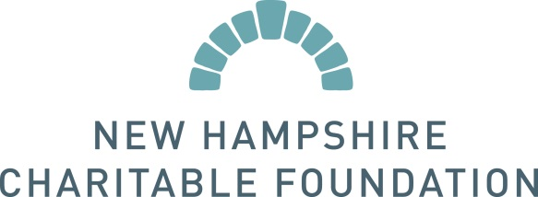
Louise Tillotson Teaching Fellowship

New Hampshire Charitable Foundation
37 Pleasant Street • Concord, NH 03301-4005
800-464-6641 • 603-225-6641 • www.nhcf.org

2018 NOMINATION FORM

Date:

Nominator’s Name: | Daytime phone #:

Address:

Title or Position: | Email:
Nominee’s Name: | Daytime phone #:
Address:
Title or Position: | Email:

NOMINATION REQUIREMENTS

- Please supply two letters of support (one at-large and one from a fellow educational professional) to support this nomination. If there are others who support this nomination, please attach brief comments from them, along with their name, title, address, email, and daytime phone number. If there are others who support the nomination, their comments and contact information may be sent along with the nomination form.

- Include a copy of a recent resume, curriculum vitae, or biography of the candidate.

- In no more than two pages, please address the following:

- How long and in want capacity have you known the nominee?
- Please describe the nominee’s commitment to public education in their school and community, excellence in teaching, and innovation in education.
- Please comment on the nominee’s professionalism and educational accomplishments.
- Please tell us why the nominee is deserving of the Louise Tillotson Fellowship.

Please email the following information by Friday, April 27, 2018 to:
Jean Clarke, Senior Tillotson Program Associate at jean.clarke@nhcf.org.

