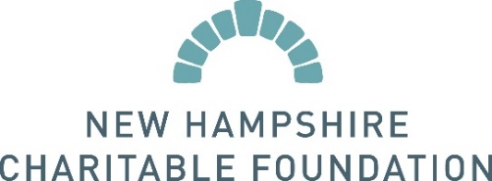
Press Release: Instructions and Template
We welcome you to use the following template to draft a press release announcing your grant from the New Hampshire Charitable Foundation. When sending the press release to your media contacts, we recommend including the text of the release in the body of the email as well as including it as an attachment.
EMAIL SUBJECT LINE: PRESS RELEASE: [Insert Press Release Title]
FOR IMMEDIATE RELEASE
CONTACT:
Contact Name
Contact Title
Organization
Phone Number
Email Address
Organization receives grant from the New Hampshire Charitable Foundation to (brief description of how the grant will be used. Ex: increase healthcare access for low-income families).
Organization recently received a $X,XXX grant from the New Hampshire Charitable Foundation. The grant will help further Organization’s mission of ____________________________ by _______________________________________.
[Insert quote from Organization’s Executive Director or other staff person]
[If desired, insert more information about the program funded by the grant]
About Organization
Place your organization’s boilerplate here: 2-5 sentence summary of the organization’s mission, including website and/or phone number.
About the New Hampshire Charitable Foundation
The New Hampshire Charitable Foundation is New Hampshire’s statewide community foundation, founded in 1962 by and for the people of New Hampshire. The Foundation manages a growing collection of more than 1,800 funds created by generous individuals, families and businesses, and awards nearly $40 million in grants and scholarships every year. The Foundation works with generous and visionary citizens to maximize the power of their giving, supports great work happening in our communities and leads and collaborates on high-impact initiatives. For more information, please visit www.nhcf.org or call 603-225-6641.
###

