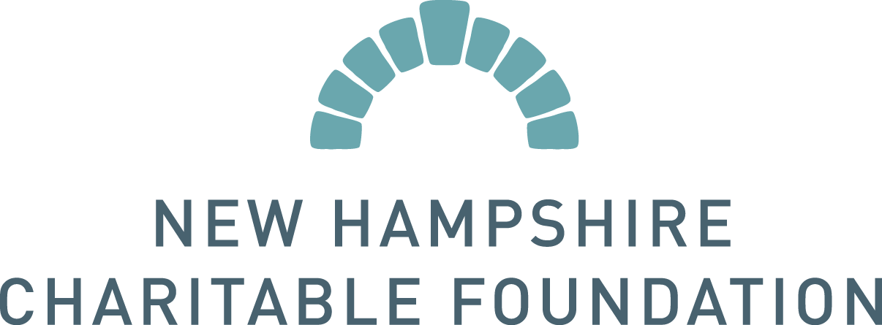

GRANT CHANGE REQUEST

Grant change requests may be approved if the request does not change the nature of the original grant purpose. Extensions of time are generally granted for 6 months. If granted an extension, a final grant report is due at the end of the time extension. Budget adjustments greater than $500 require approval from the Foundation.

When requesting a change, please include the following information:

Date of Request Click here to enter a date.

Name of Organization Click here to enter text.

Grant ID (from award letter; ex: PR15-1234) Click here to enter text.

A brief explanation of why you are requesting the change – describe your proposed change for the use of funds, work plan, budget or timeline. If this is a budget change, please submit an amended budget that shows the original budget with proposed amendments or line item reallocations. Or email a separate document with this form Click here to enter text.

To submit a change request, please save this document to your files, then email it to grants_info@nhcf.org – the subject line of your email should contain the grant ID number and “Grant Change Request”. You may be contacted for more information by a member of our staff.

--------------------------------------------------- INTERNAL USE ONLY --------------------------------------------------------

Approved ☐

Declined ☐

Date Click here to enter a date.

SPO Choose an item.

SPOs please inform the NPO and email completed form to frontdesk@nhcf.org

