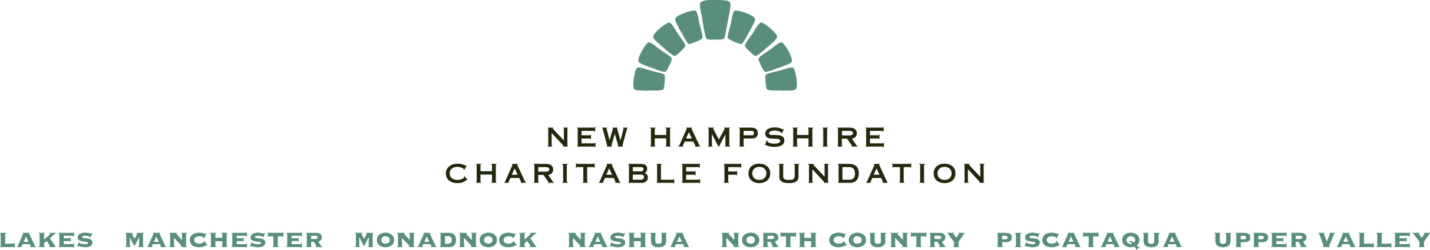
WELLBORN ECOLOGY FUND – 2016 APPLICATION FORM
This form should be saved to your computer before you complete it. Please complete it in full and submit it along with attachments by close of business on the day of the deadline. You may use the TAB key to move around the document. All attachments you need to send with this form appear on the last page of the form.

Date: Region to which you are applying: UPPER VALLEY

APPLICANT CONTACT INFORMATION
Applicant Organization Name:

EIN: Website URL: www.

Street Address/PO Box: City: State: Zip:

CEO/Executive Director: Phone: ( )- - Ext: E-mail:

Contact for Application (if different from CEO/ED): Title:

Phone: ( )- - Ext: E-mail:
Fiscal Sponsor Information (Complete ONLY if applicant is not a 501(c)3 public charity)
Name:
EIN: Website URL: www. Phone Number: ( ) - - ext:
Street Address/PO Box: City: State: Zip:
CEO/Executive Director: E-mail:

APPLICANT GENERAL INFORMATION
Year Founded: Number of Clients Served per year: Field of Service:

Geographic Area Served by Organization:

Number of Paid Staff: (indicate in FTEs)

Organization’s Current Annual Operating Budget: $ Operating Budget for Past Year: $

APPLICATION REQUEST
Type of Funding (check one) Discrete Project Program Support

Total Amount Requested: $ (up to $5,000)

Purpose of Request: “This grant will be used to .” (15 words or less)

PRIOR SUPPORT
Please list prior Wellborn grant awards, if applicable:

1. Amount: $ Date Received: Brief Purpose:

2. Amount: $ Date Received: Brief Purpose:

3. Amount: $ Date Received: Brief Purpose:

PROPOSAL DETAILS
Please respond to each question in the box provided. Suggested word limits are provided for each box. You may cut and paste into this section from a Word document. Please limit this section to a total of no more than three (3) pages.

Executive Summary of proposed project/program, its importance, and the results you expect (100 words):

Need – Describe the need or opportunity for the proposed work in your school/community (200 words):

Project Description – Describe the proposed project/program, including major activities, key people involved and timetable (250 words):

Wellborn Goals – Describe how your project/program advances one or more Wellborn goals (250 words):

Results – If your project/program is successful, what will be different as a result of your work? (150 words)

List up to three specific measurable outcomes you intend to achieve in the coming year. Please note where possible the mechanism by which you measure these outcomes (50 words each):
1.

2.

3.

Sustainability – If this work is ongoing, how will you sustain it—both programmatically and financially—beyond the grant? How does it advance organizational goals and create lasting benefit for your school or community? (150 words):

SUBMISSION REQUIREMENTS - With this form please include the following materials*:

All Applicants:
Project/Program Budget and Narrative (using Excel template provided at www.nhcf.org/wellborn)

Organizational Budget for proposed grant year (either the current or forthcoming fiscal year, depending on when grant funds would be utilized).

Optional:
Letters of support (up to two one-page letters may be submitted)

Applicants Applying with a Fiscal Sponsor:
Updated Fiscal Sponsorship Agreement Form (available on www.nhcf.org)

(*Other application forms and grant-program information can be found at www.nhcf.org/wellborn. Note that applicants may be asked to supply additional information upon request during the review process.)

Email your application form and attachments by 5 p.m. on Friday, July 22, 2016 to Kevin Peterson at kp@nhcf.org. Please be sure the subject of your email starts with “Wellborn”, followed by you organization name (e.g. “Wellborn-Franklin Elementary School”). Please attach your application materials rather than copying them into the text of the email. You may put all application materials into one PDF to attach to the email. Please do not send zipped files or files in a “read only” format.

Thank you for your grant application. Please note that an application for Wellborn support does not constitute a guarantee of funding. Grant decisions will be announced by early August. If you have any questions, please contact Kevin Peterson at 603-263-8370, or by email kp@nhcf.org.

